A MINI PROJECT REPORT ON

**SMART DONOR**

A dissertation submitted in partial fulfilment of the

Requirements for the award of the degree of

**BACHELOR OF TECHNOLOGY**

in

**INFORMATION TECHNOLOGY**

***Submitted by***

**T.SAI CHARAN (18B81A1288)**

**P.SAI CHARAN REDDY (18B81A1289)**

**P.YASHWANTH REDDY (18B81A12B9)**

***Under the guidance of***

**Dr. D.BHANU MAHESH**

Assistant Professor, IT Department

CVR College of Engineering

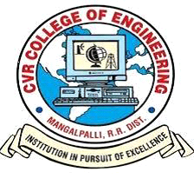

**DEPPARTMENT OF INFORMATION TECHNOLOGY**

**CVR COLLEGE OF ENGINEERING**

ACCREDITED BY NBA, AICTE & Affiliated to JNTU-H

Vastunagar, Mangalpally (V), Ibrahimpatnam (M), R.R. District, PIN-501 510

2021-2022

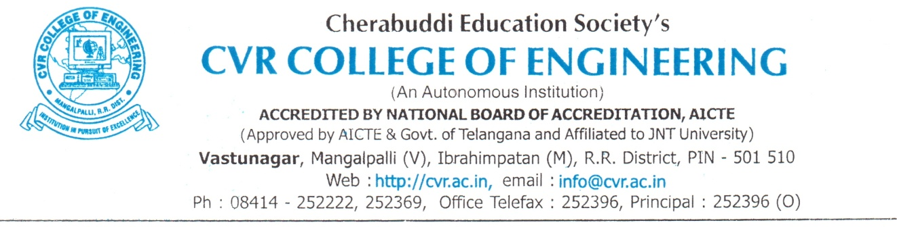

**DEPARTMENT OF INFORMATION TECHNOLOGY**

**CERTIFICATE**

This is to certify that the Project Report entitled **“SMART DONOR”** is a bonafide work done and submitted by **T.Sai Charan (18B81A1288)**, **P.Sai Charan Reddy(18B81A1289)**, **P.Yashwanth Reddy (18B81A12B9)** during the academic year 2021-2022, in partial fulfilment of requirement for the award of Bachelor of Technology degree in Information Technology from Jawaharlal Nehru Technological University Hyderabad, is a bonafide record of work carried out by them under my guidance and supervision.

Certified further that to my best of the knowledge, the work in this dissertation has not been submitted to any other institution for the award of any degree or diploma.

**INTERNAL GUIDE** **PROJECT COORDINATOR**

**Mr. D. Bhanu Mahesh G.Sunitha Rekha**

Assistant Professor, IT Department Associate Professor, ITDepartment

**HEAD OF THE DEPARTMENT**

**Dr.Bipin Bihari Jayasingh**

Professor, IT Department

**EXTERNAL EXAMINER**

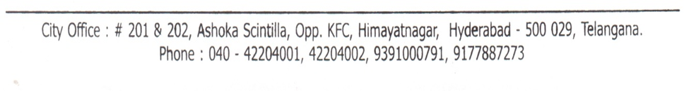

**DECLARATION**

We hereby declare that the project report entitled “**Smart Donor**” is an original work done and submitted to IT Department, CVR College of Engineering, affiliated to Jawaharlal Nehru Technological University Hyderabad, Hyderabad in partial fulfilment of the requirement for the award of Bachelor of Technology in **Information Technology** and it is a record of bonafide project work carried out by us under the guidance of **Mr. D. Bhanu Mahesh, Department of Information Technology.**

We further declare that the work reported in this project has not been submitted, either in part or in full, for the award of any other degree or diploma in this institute or any other Institute or University.

Signature of theStudent

(T.Sai Charan)

(18B81A1288)

_____________________

Signature of the Student

(P.Sai Charan Reddy)

(18B81A1289)

_____________________

Signature of the Student

(P.Yashwanth Reddy)

(18B81A12B9)

_____________________

**ACKNOWLEDGEMENT**

The satisfaction of completing this project would be incomplete without mentioning our gratitude towards all the people who have supported us. Constant guidance and encouragement have been instrumental in the completion of this project.

First and Foremost, We thank the Chairman, Principal, Vice Principal for availing infrastructural facilities to complete the mini project in time.

We offer our sincere gratitude to our internal guide **Mr. D. Bhanu Mahesh,** Professor, IT Department, CVR College of Engineering for his immense support, timely co-operation and valuable advice throughout the course of our project work.

We would like to thank the Head of Department, Professor **Dr. Bipin Bihari Jayasingh**, for his meticulous care and cooperation throughout the project work.

We are thankful to **G.Sunitha Rekha,**Project Coordinator, Associate Professor, IT Department, CVR College of Engineering for his supportive guidelines and for having provided the necessary help for carrying forward this project without any obstacles and hindrances.

We also thank the **Project Review Committee Members** for their valuable suggestions.

**ABSTRACT**

Smart Donor is a website, that acts a bridge between an organ donor and a patient who needs them. Smart Donor is a platform that finds donors from across the nation, verifies their health background by a team of specialized doctors and then these donors details are made online. When a patient who needs an organ visits our website can have access from a wide range of donors who are willing to donate their organs. This process makes patients to find their needs in a fast and easy manner. SmartDonor also have connections with all the hospitals and the state governments to donate organs who all need them.

**LIST OF FIGURES**

|  |  |  |
| --- | --- | --- |
| **Figure No.** | **Title** | **Page No.** |
| 1 | Use Case | 18 |
| 2 | Flow Chart | 19 |
| 3 | Sequence Diagram | 20 |
| 4 | User-Interface Diagram | 21 |
| 5A,5B | Index Page | 23 |
| 6A,6B | Registration Page | 24 |
| 7A,7B | Registering User in Database | 25 |
| 8 | Login Page | 26 |
| 9A,9B | Validating user credentials for login | 27 |
| 10A,10B | Organ Requesting Page | 28 |
| 11A,11B | Storing Donation Details of User in Database | 29 |
| 12A,12B | Organ Donation Page | 30 |
| 13A,13B | Storing Organ Request Details in Database | 31 |
| 14 | Home Page (Before Login) | 33 |
| 15 | Registration Page | 33 |
| 16 | Login Page | 34 |
| 17 | Home Page (After successful login) | 34 |
| 18 | Orgon Donation Page | 35 |
| 19 | Organ Requesting Page | 35 |
| 20 | Home Page showing Active Requests | 36 |
| 21 | User Profile Page | 36 |

**TABLE OF CONTENTS**

**S.No Topic Pg.No**

**1 Introduction…………………………………………………… 10**

**2 Software Requirements Specification……………………….. 15**

**3 Design………………………………………………………….. 17**

**4 Implementation……………………………………………….. 22**

**5 Testing…………………………………………………………. 32**

**Conclusion……………………………………………………... 37**

**Future Enhancements…………………………………………. 38**

**References……………………………………………………... 39**

**CHAPTER 1**

**INTRODUCTION**

## 

#### **INTRODUCTION**

In the 50 years since the first successful organ transplant, thousands of recipients of a transplanted kidney, heart, pancreas, liver, or other solid organ in the United States and throughout the world have had their lives extended and their health enhanced as a result of organ transplantation.

Organ transplantation is unique among surgical procedures, in that the procedure cannot take place without the donation of an organ or a partial organ from another person. Since 1988, more than 390,000 organs have been transplanted, with approximately 80 percent of the transplanted organs coming from deceased donors. In 2005, 7,593 deceased donors provided 23,249 transplanted organs in the United States, and there were 6,896 living donors (OPTN, 20061).

The success of organ transplantation as a treatment option, the rising incidence of related or contributory medical conditions, improvements in immunosuppressive medications, and other factors have resulted in a rapid escalation in the waiting list for transplantation2 in recent decades. In 1988, there were 16,026 individuals on the waiting list for an organ transplant; by 1995 the waiting list had increased almost 275 percent to 43,937; and Data are provided from the National Data Reports on the OPTN website (www.optn.org). The data used in this chapter are current as of March/April 2006; data on the website are continuously updated.The waiting list is not strictly hierarchical, as recipients are matched to donors by the use of a number of allocation factors, including geographic proximity, blood type, and genetic characteristics.

FIGURE 1-1 Growth in the number of transplants and in the number of candidates on the transplant waiting list.

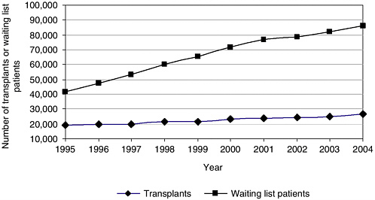

has since more than doubled so that by January 2006 the waiting list topped 90,000 individuals (Figure 1-1) (IOM, 1999; OPTN, 2006). The waiting list is primarily driven by the need for kidney transplants. The statistics on the transplant waiting list are continually updated, and as of March 24, 2006, there were 91,214 transplant candidates3 on the waiting list, of whom 65,917 individuals (approximately 70 percent of the waiting list) were candidates for kidney transplantation. In 2005, 44,619 transplant candidates were added to the waiting list (OPTN, 2006).

As the demand for organ transplants far exceeds the current supply of available organs, various efforts are under way to determine how best to reduce the gap between supply and demand. In addition to refinements in hospital processes and protocols, several proposals are being discussed that the waiting list is dynamic and changes throughout the year as new candidates and registrations are added, individuals receiving a transplant are removed, and other changes are made. OPTN provides data on the number of waiting list candidates and registrations. These numbers differ because one waiting list candidate may have multiple registrations. For example, a patient who is listed through more than one center or for multiple organs would have multiple registrations. Throughout this report, the statistics used are for transplant candidates, unless indicated otherwise the text might further enhance the system or provide incentives for more individuals or families to consent to organ donation

In 2004, the Health Resources and Services Administration (HRSA) and The Greenwall Foundation asked the Institute of Medicine (IOM) to study the issues involved in increasing the rates of organ donation. This report is the result of a 16-month study conducted by an IOM committee composed of experts in the fields of bioethics, law, health care, organ donation and transplantation, economics, sociology, emergency care, end-of-life care, and consumer decision making.

###### **PROBLEM STATEMENT**

* 17 people die every day waiting for an organ transplant
* 107,000+ Number of men, women, and children on the national transplant waiting list as of February 2021.
* Every 9 minutes another person is added to the transplant waiting list.

Watching the above stats we can assume how much there is a need for organ donation in the world. To make this work easy we have come up with an easy way to develop a website that connects donors and patients from any part of India.

###### **OBJECTIVES**

1. To deploye a fully functional website that briges all the donors and patients who is in need of on organ.

# 1.1 LITERATUTE SURVEY

* Limitations of the existing works :
  1. <https://www.apollohospitals.com/organ-donation/>
  2. <https://www.organdonor.gov/register.html>

All of the existing websites only accept donors to get registered online. But any of the websites don't have a platform to connect donors and patients from across the nation.

* Literature Review :

We have contacted a nearest hospitals and came to know that society has almost zero knowledge about organ donation, also even if they know they don’t have a clear idea how the process can be done.

**CHAPTER 2**

**Software Requirement Specifications**

* **Functional requirements**
  1. **Authentication of the user whenever he/she logs in to the system.**
  2. **Verifies user whenever he/she donates an organ.**
  3. **Verifies user whenever he/she requests for an organ.**
* **Non-Functional requirements**
  1. **Any request placed by registered user should be verified within 24 hrs.**
  2. **In case of emergency of an organ user can request for an organ while verification will be under process. If at any point of time user verification fails he/she can not move forward with the same request and need to place a new request.**

**CHAPTER-3**

**DESIGN**

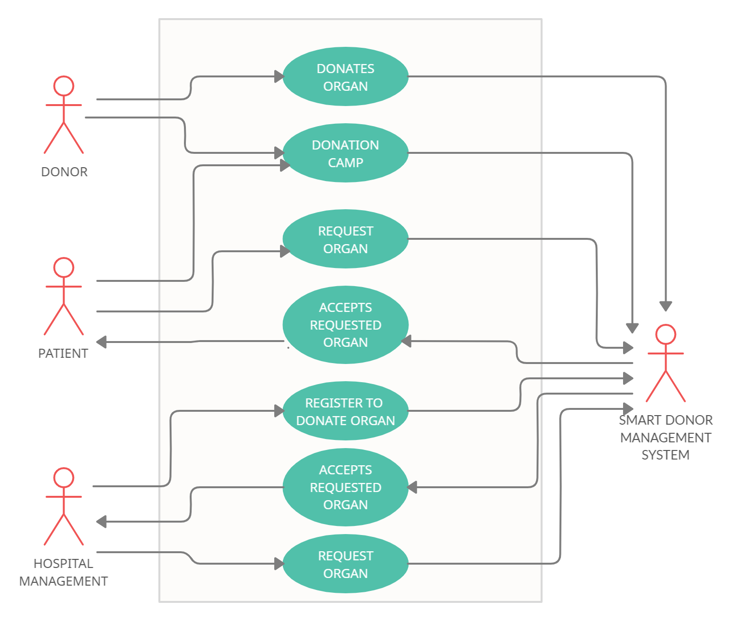

**USE CASE DIAGRAM**

**FIGURE-1**

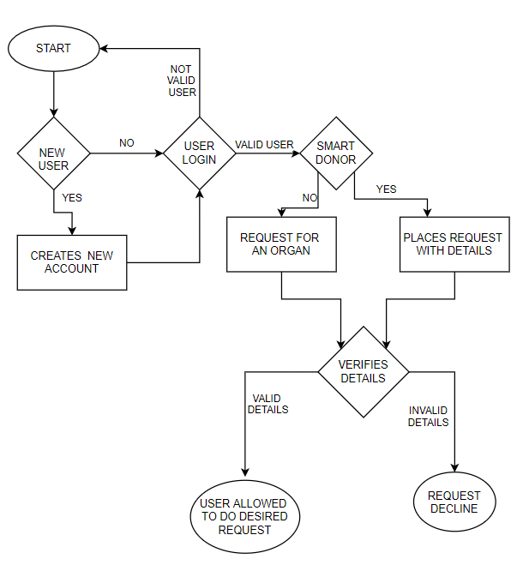

**FLOW CHART**

**FIGURE-2**

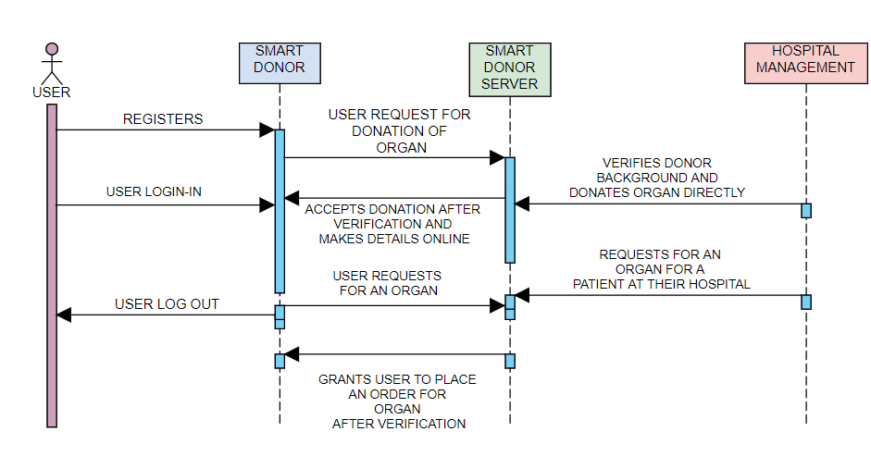

**SEQUENCE DIAGRAM**

**FIGURE-3**

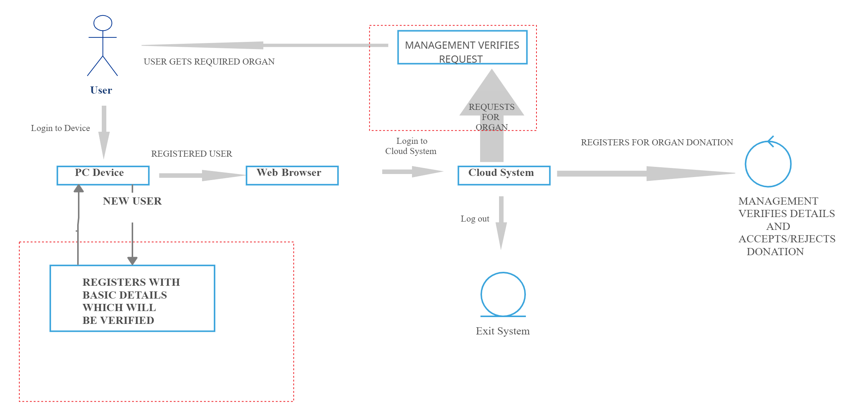

**USER-INTERFACE DIAGRAM**

**FIGURE-4**

**CHAPTER-4**

**IMPLEMENTATION**

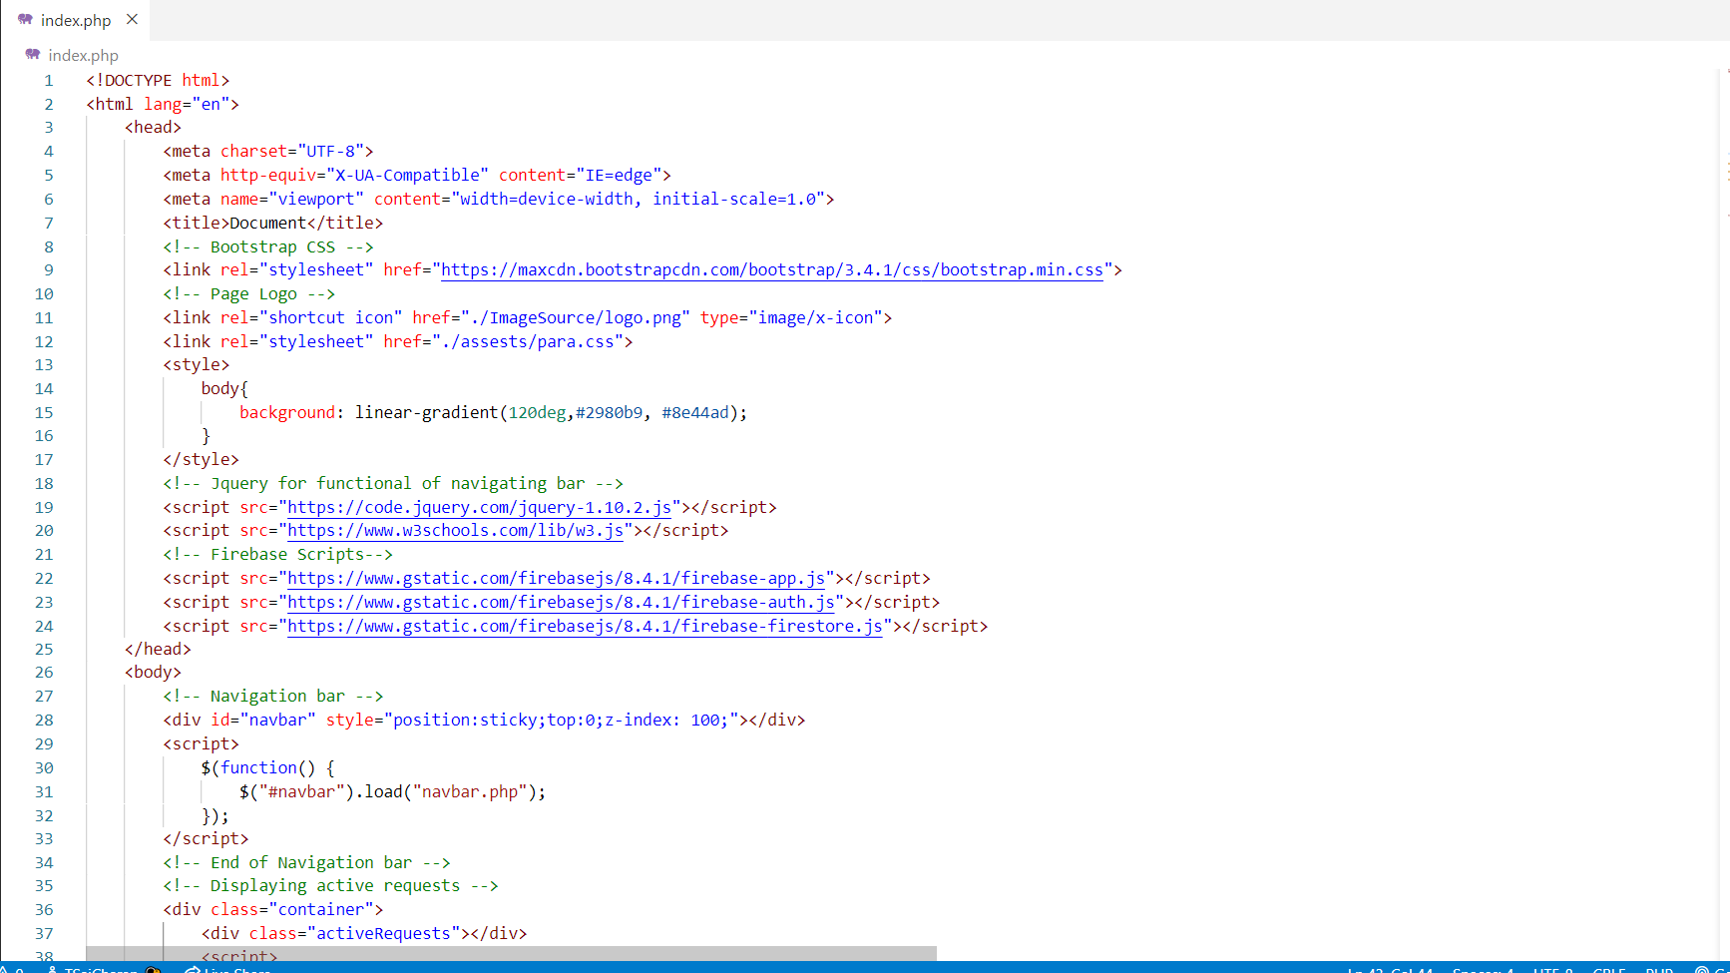

**FIGURE-5A**

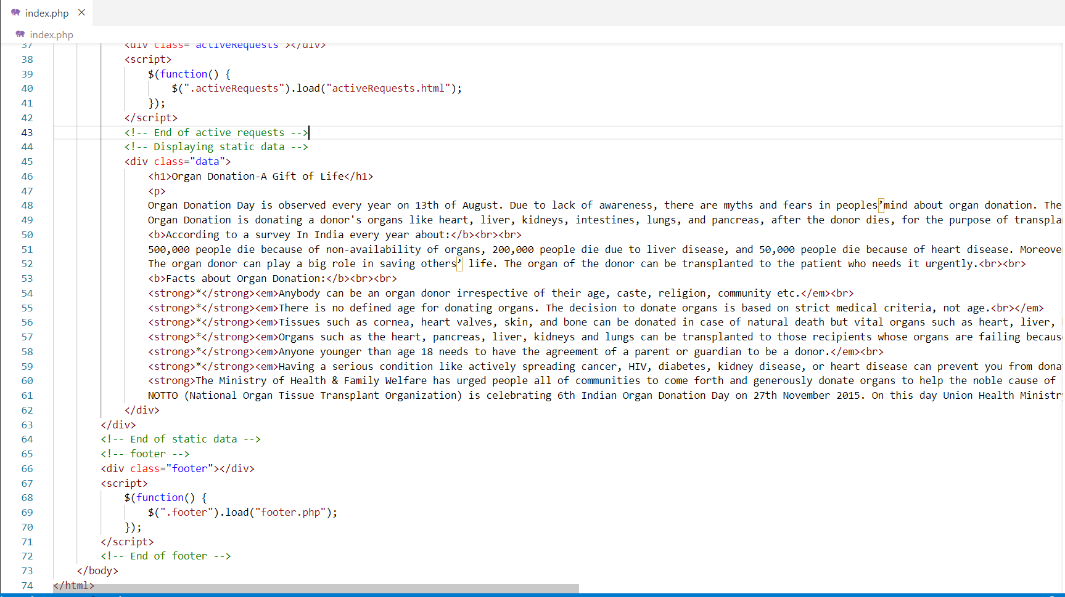

**FIGURE-5B**

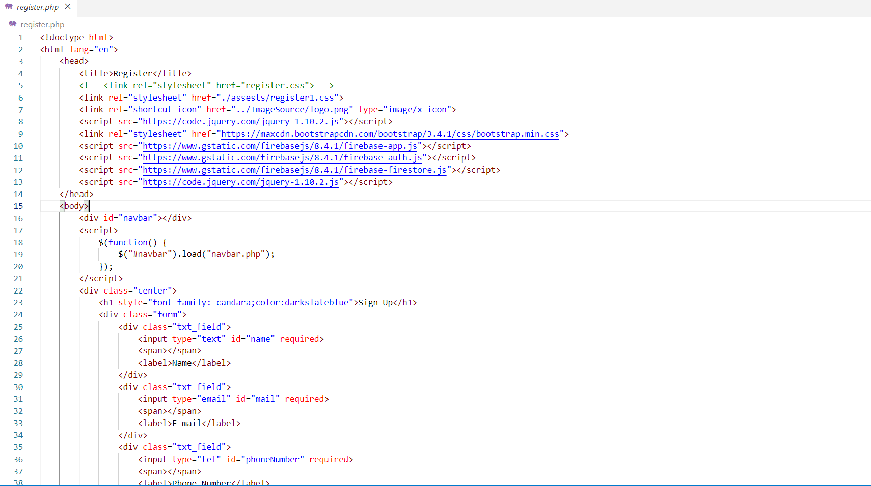

**FIGURE-6A**

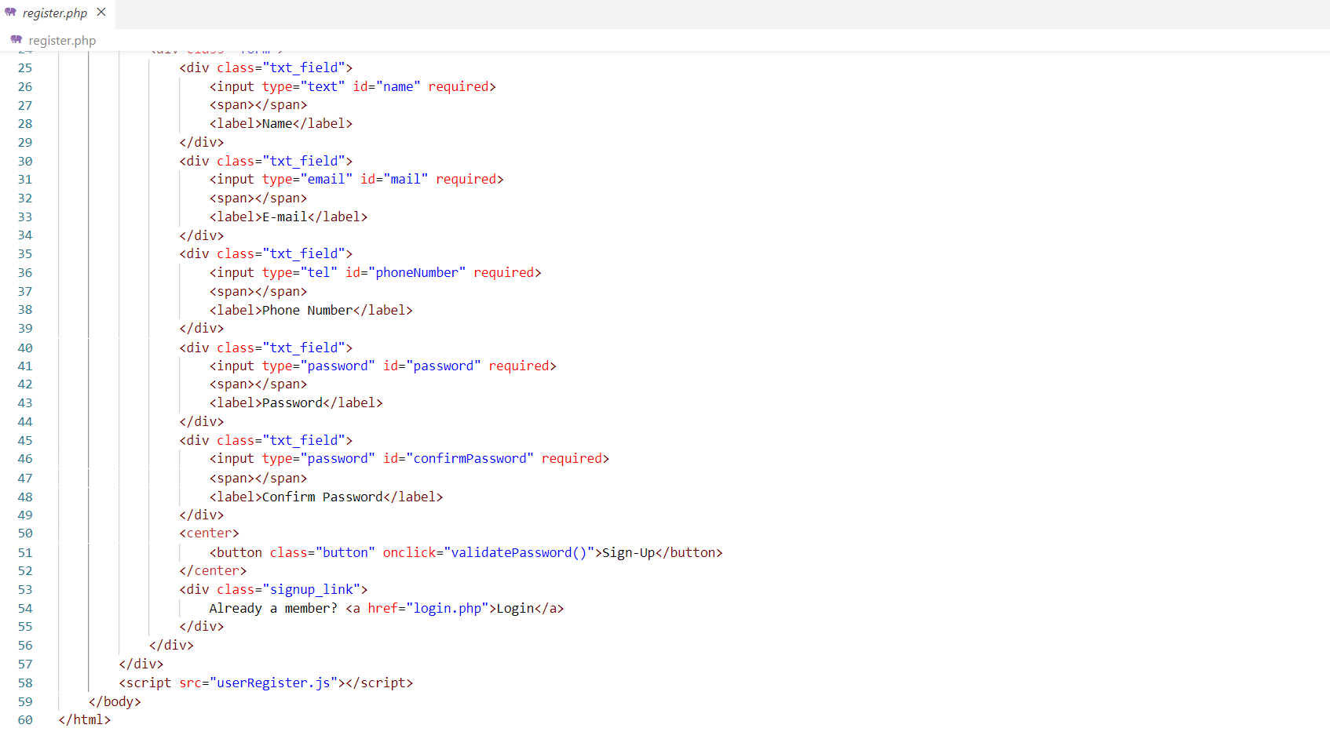

**FIGURE-6B**

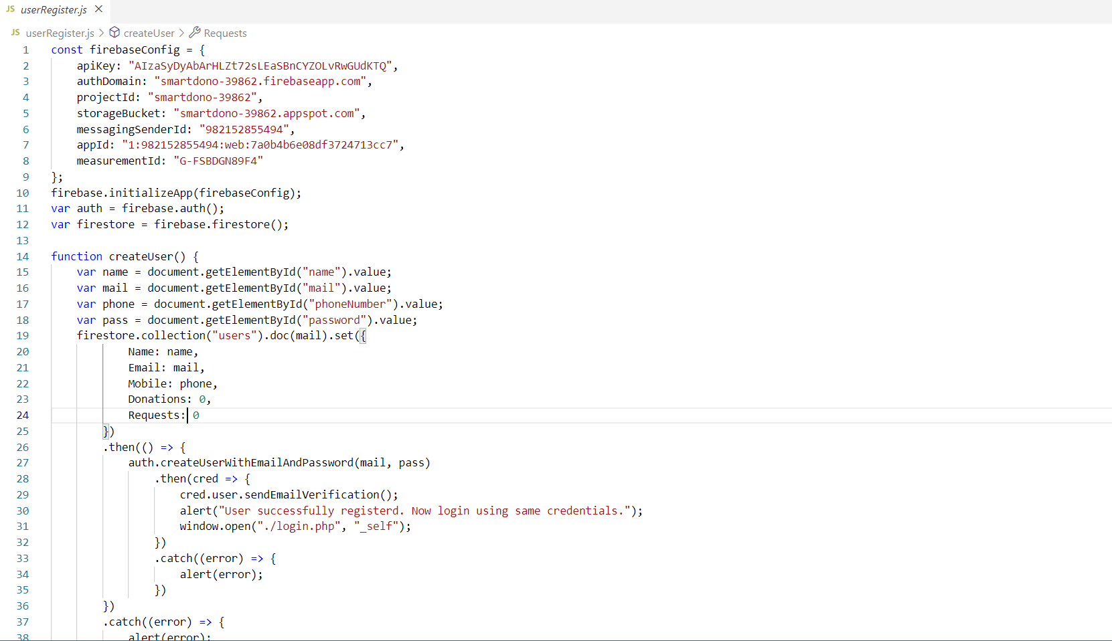

**FIGURE-7A**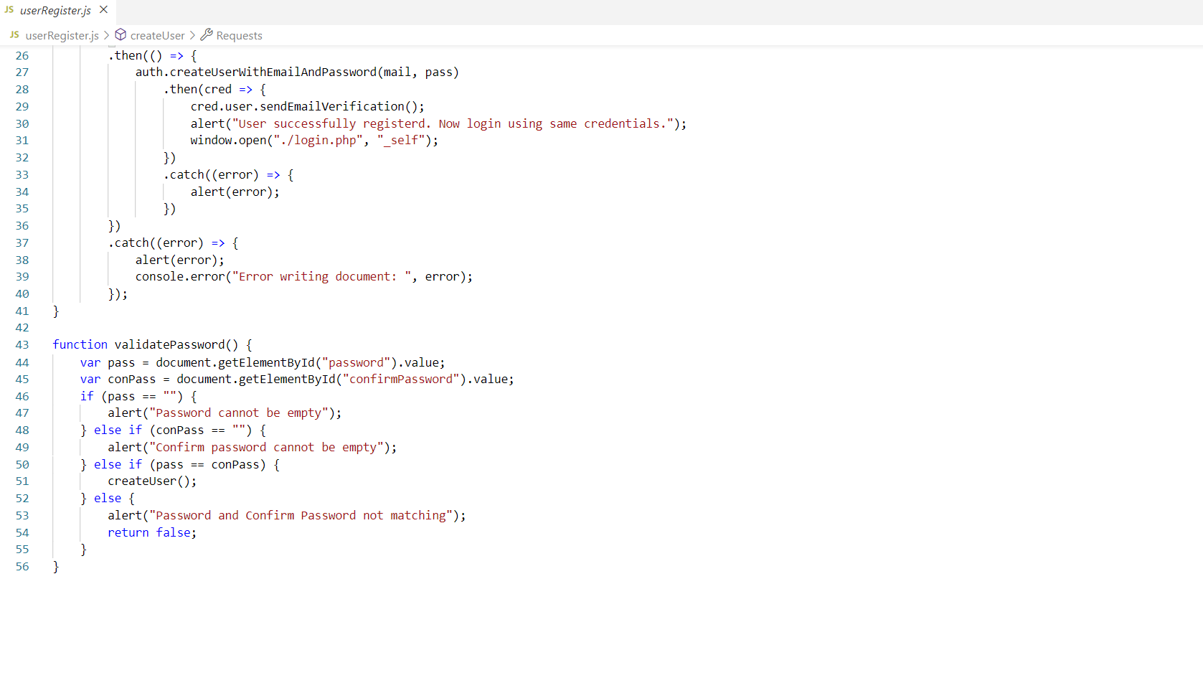

**FIGURE-7B**

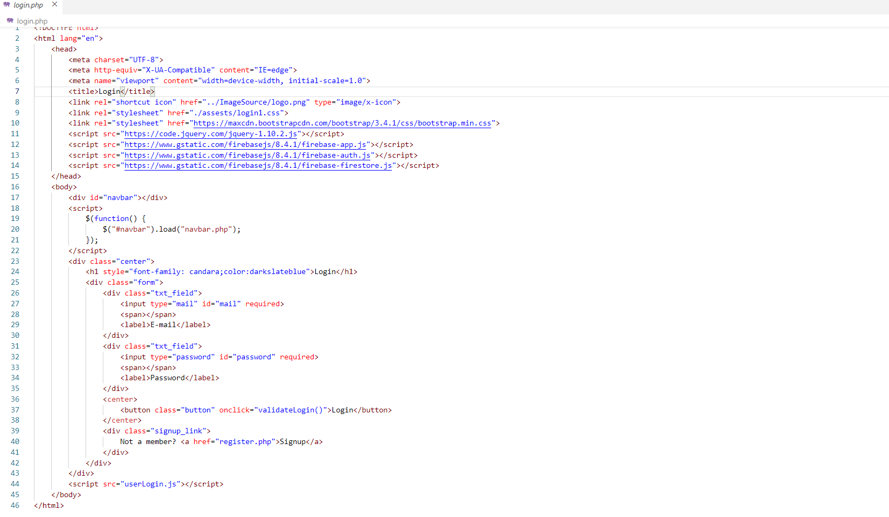

**FIGURE-8**

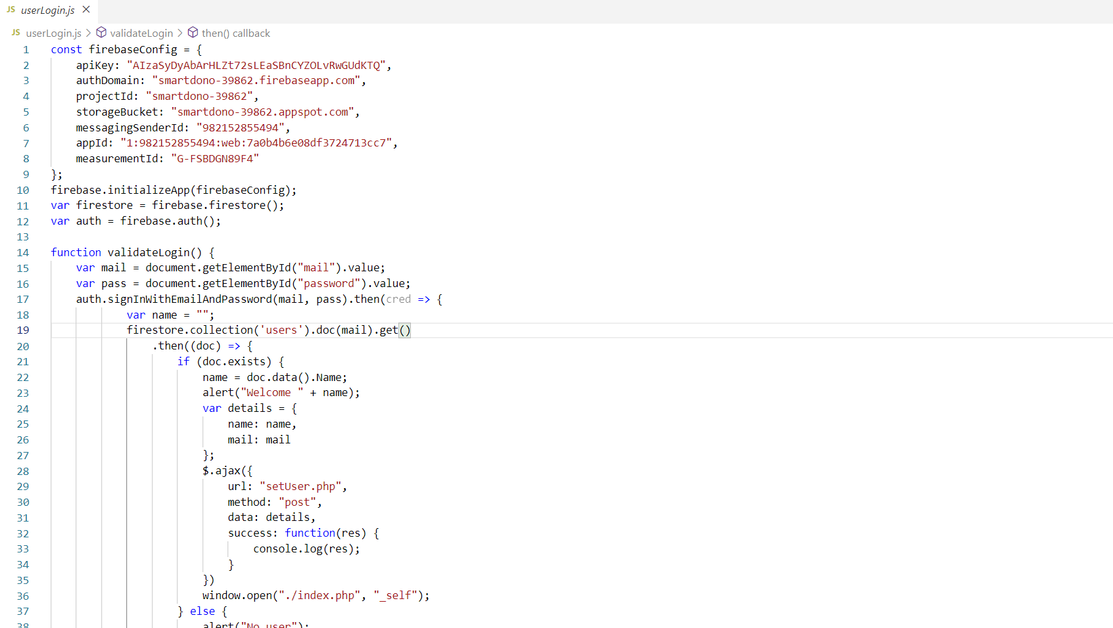

**FIGURE-9A**

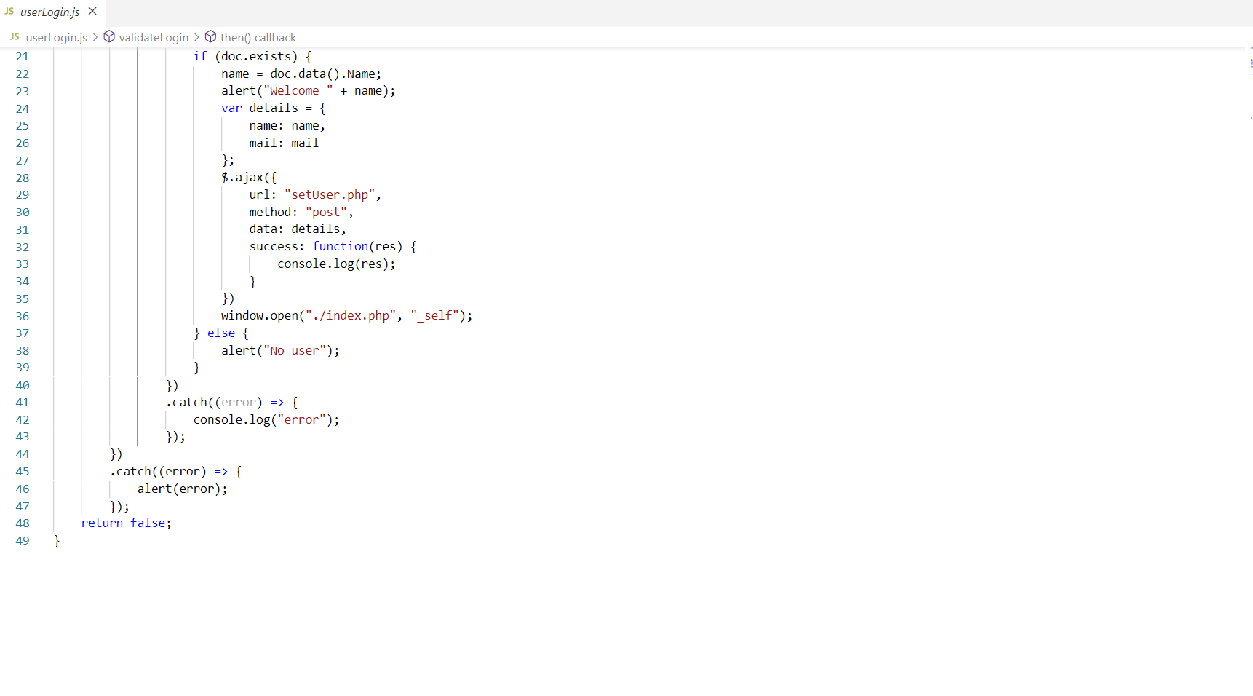

**FIGURE-9B**

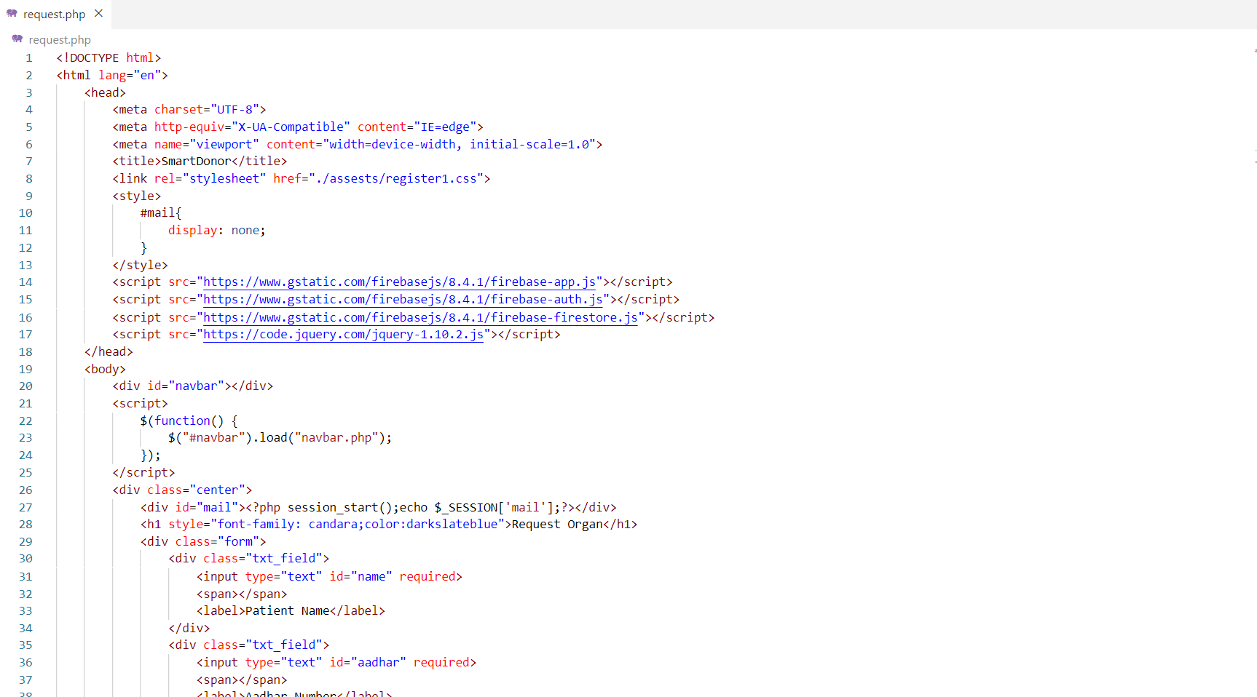

**FIGURE-10A**

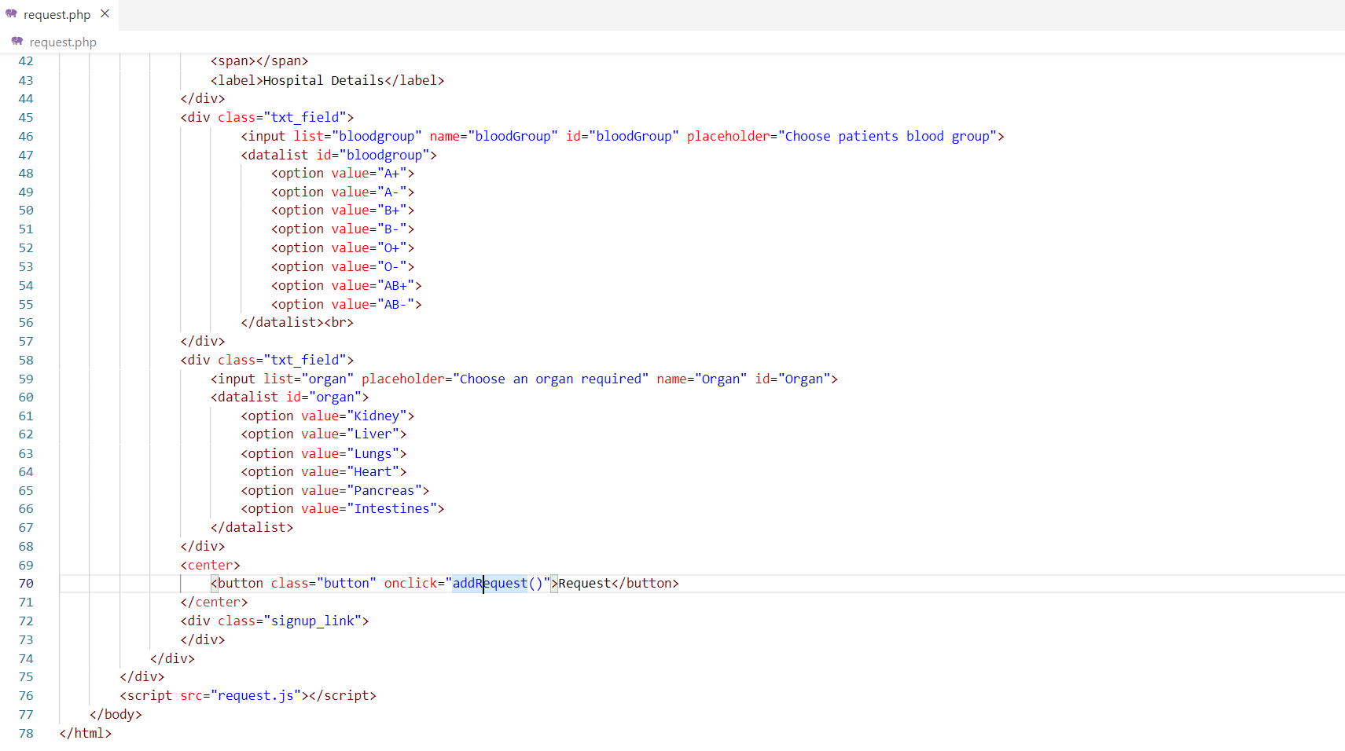

**FIGURE-10B**

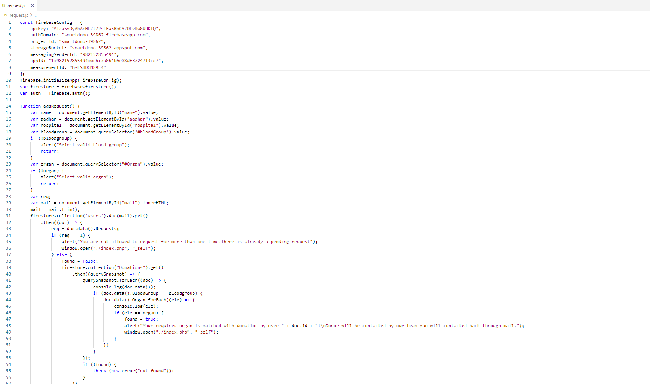

**FIGURE-11A**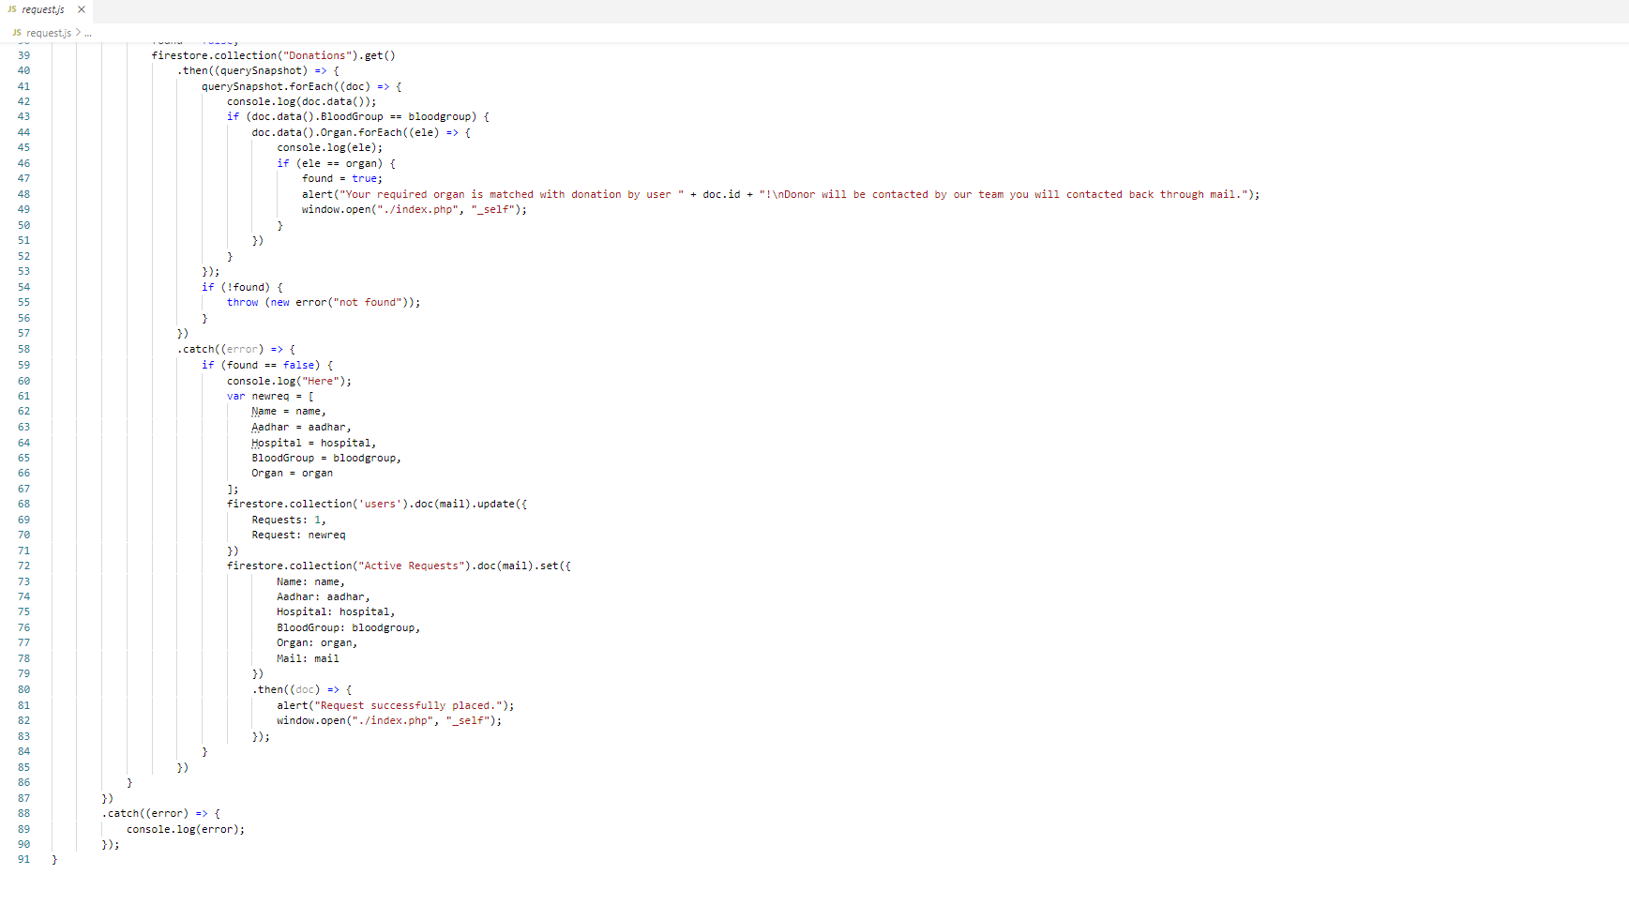

**FIGURE-11B**

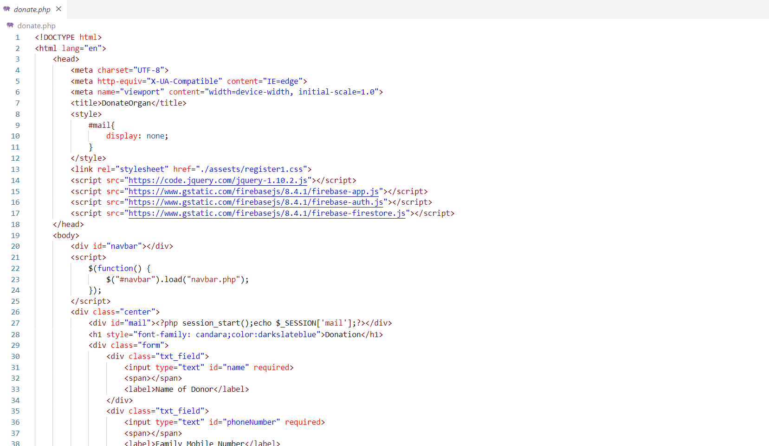

**FIGURE-12A**

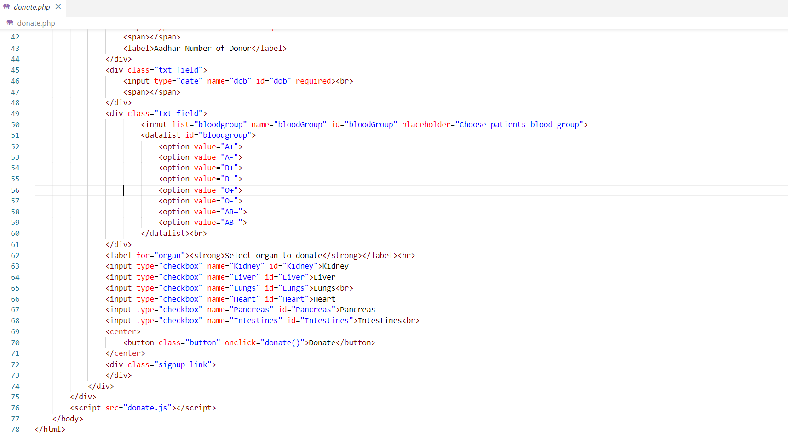

**FIGURE-12B**

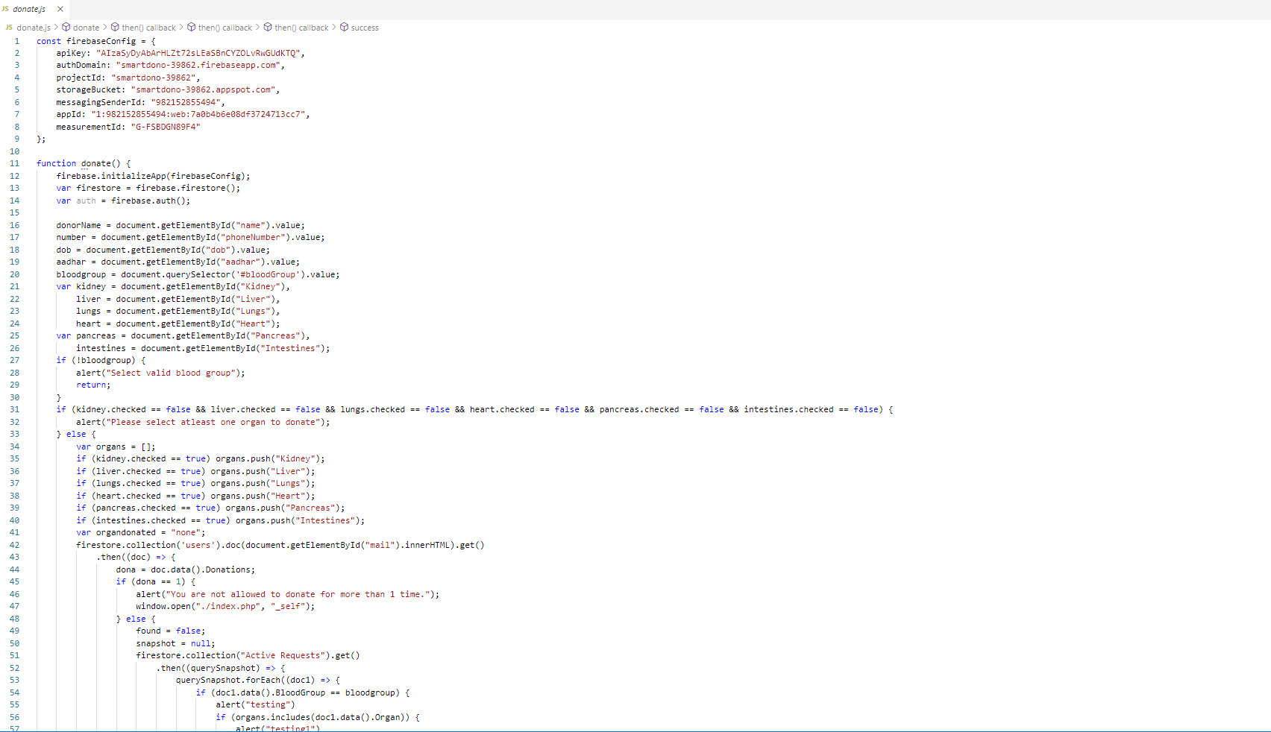

**FIGURE-13A**

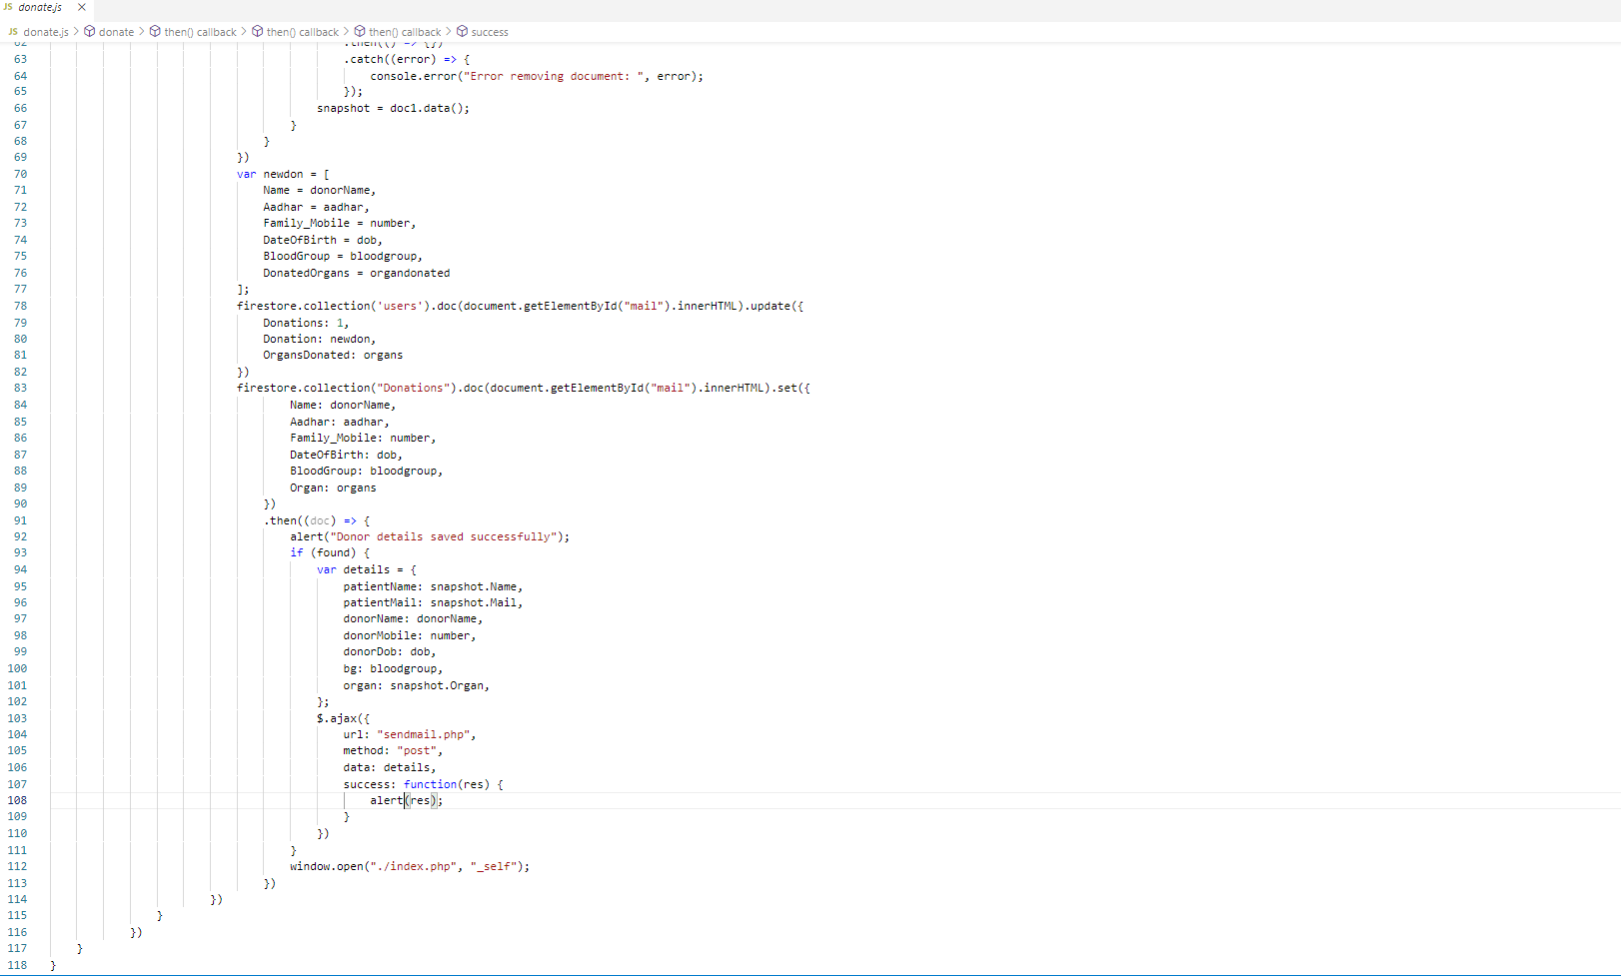

**FIGURE-13B**

**CHAPTER-5**

**TESTING**

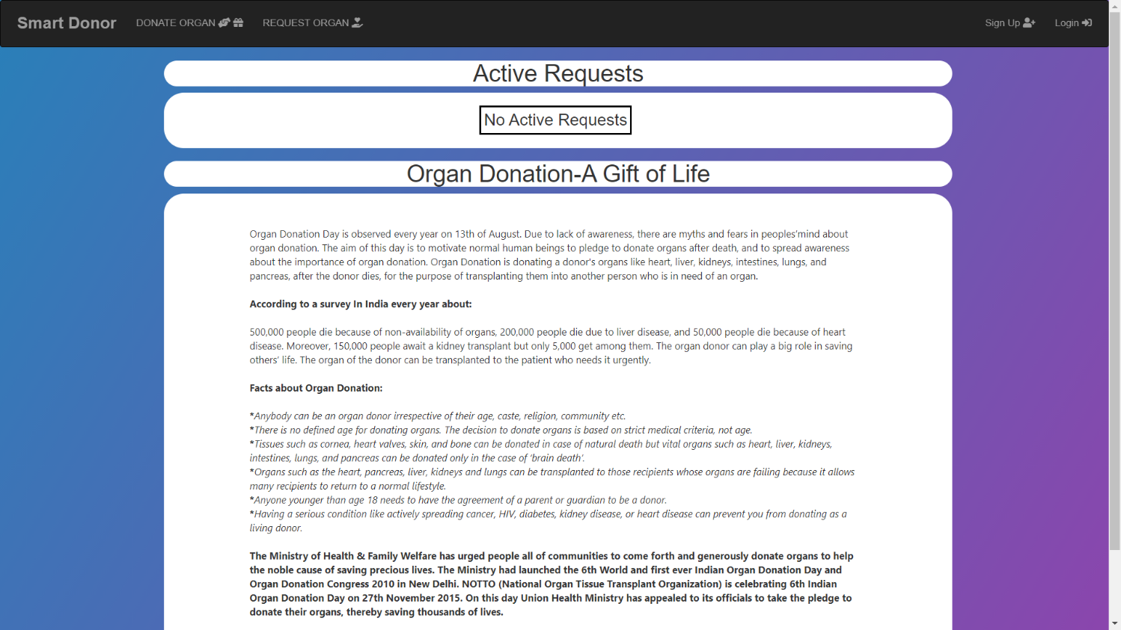

**FIGURE-14**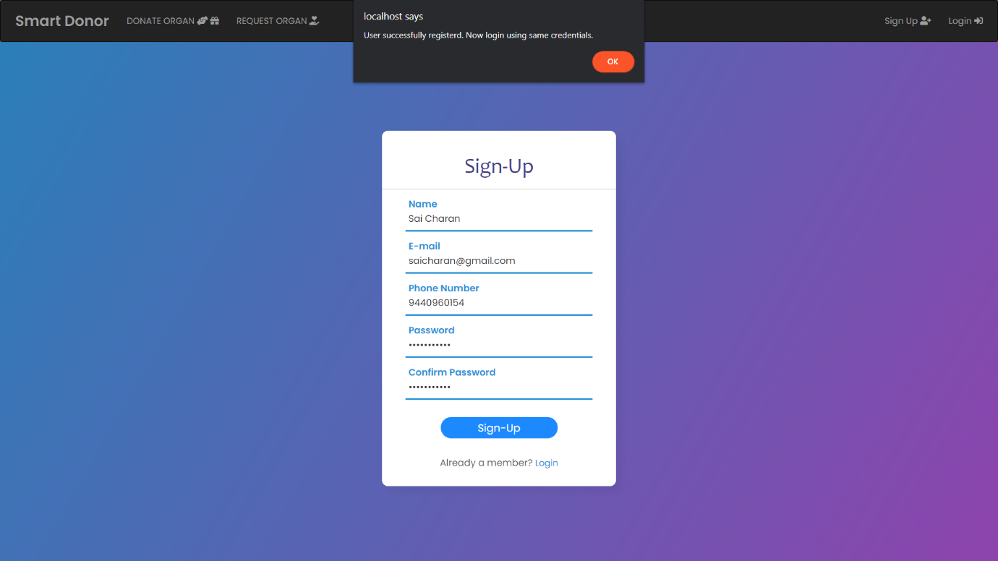

**FIGURE-15**

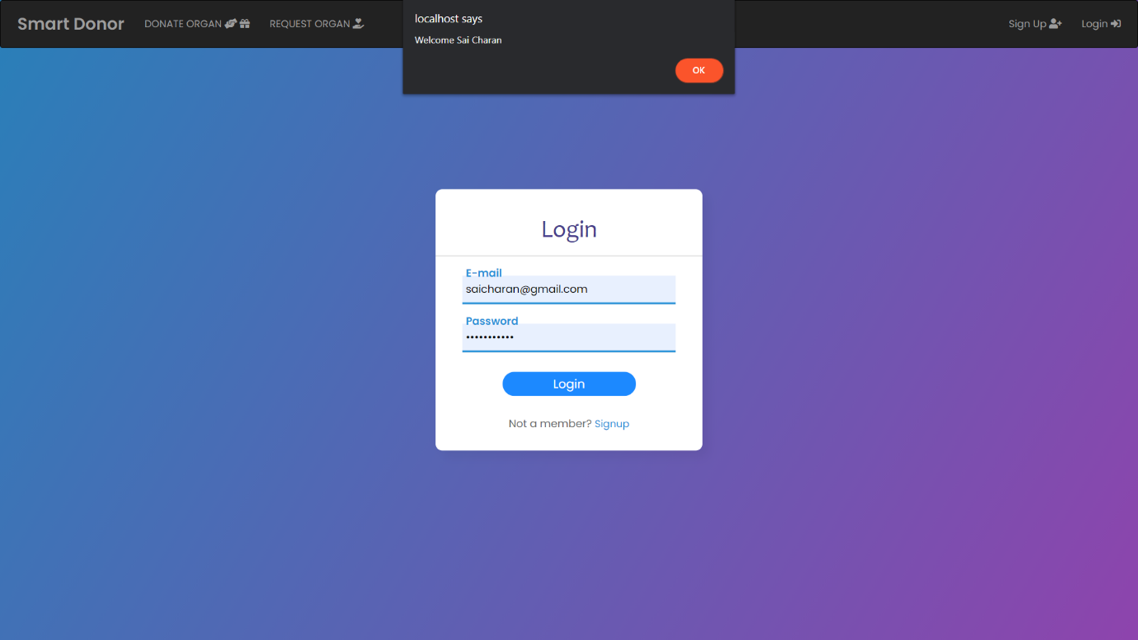

**FIGURE-16**

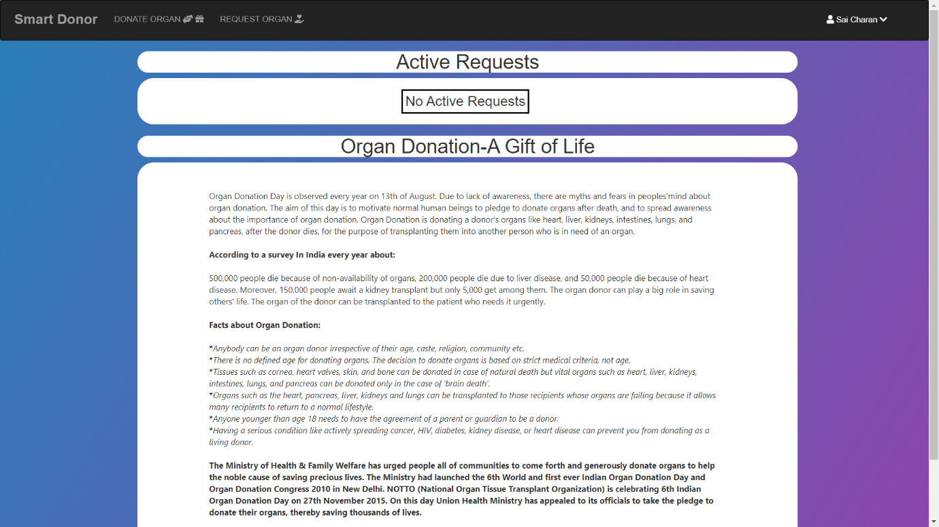

**FIGURE-17**

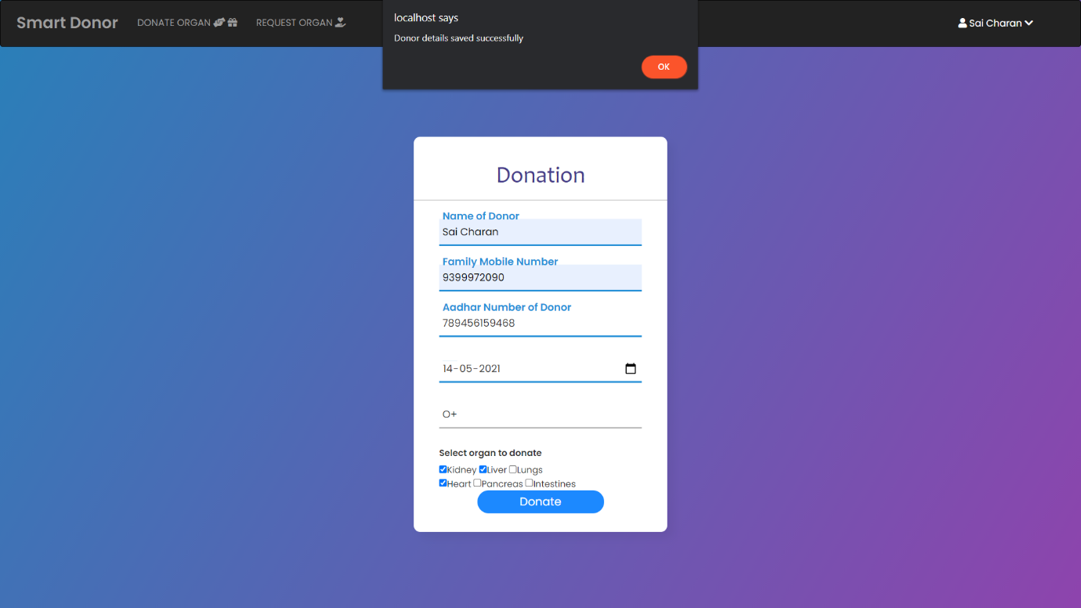

**FIGURE-18**

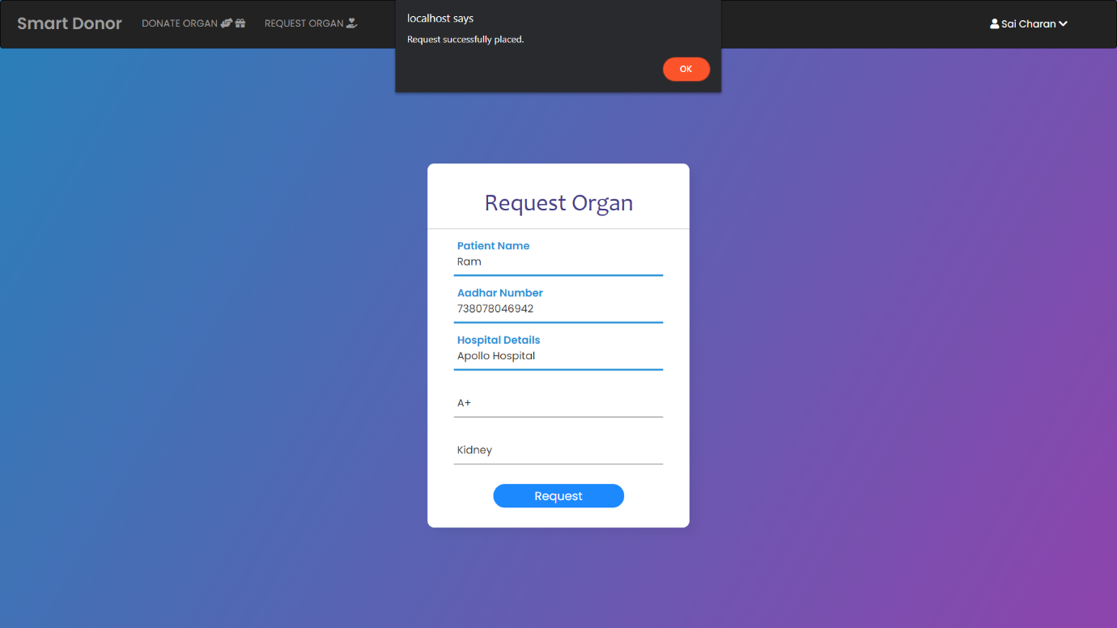

**FIGURE-19**

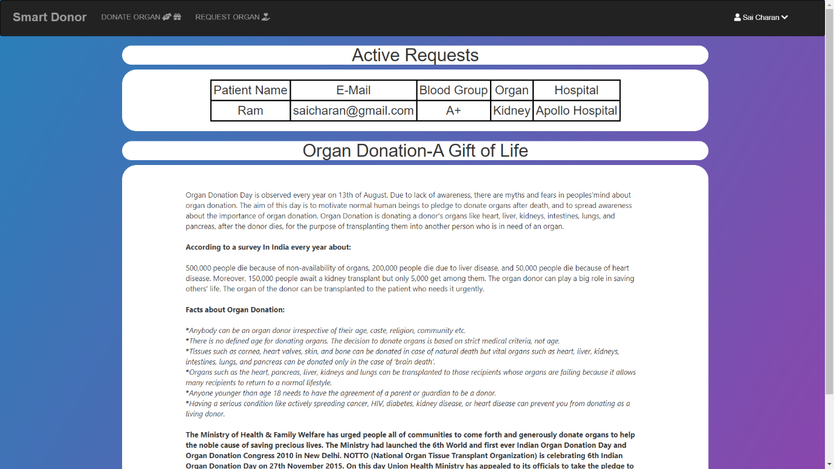

**FIGURE-19**

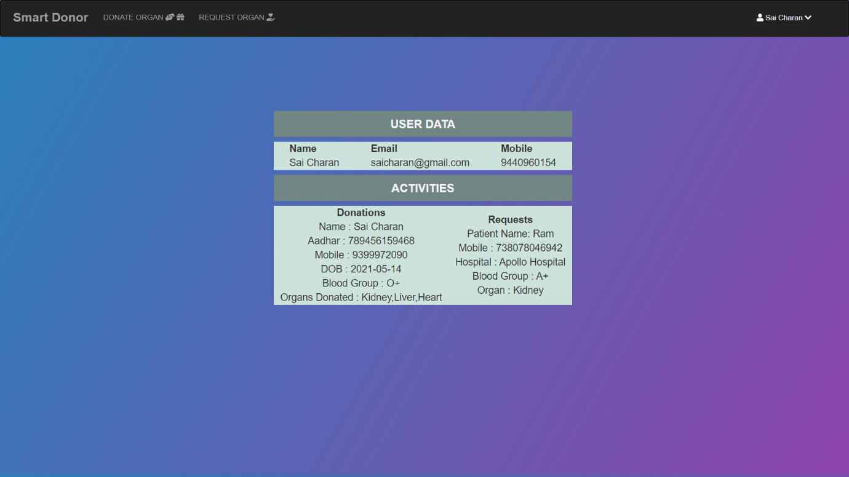

**FIGURE-20**

**CONCLUSION**

SmartDonor has been tested for various scenarios to check whether it is working as expected. The designed website can be able to store donor details and patients who request organs confidentially. Also user login credentials are never known to anyone so that visibility of these details is almost 0%.

###### **FUTURE ENHANCEMENT**

Currently SmartDonor has no feature that communicates with local government and private hospitals. So when this website can have connections with hospitals it can serve its users more productively. Some operations that can be achived are more donors can be able to be registered directly from hospitals aswell as organ donation to the one who need can be directly from one hospital to another.

**REFERENCES**

1. Campbell, Jennifer (2017). *Web Design: Introductory*. Cengage Learning. p. 27.
2. Bureau of Labor Statistics, U.S. Department of Labor. "Information Security Analysts, Web Developers, and Computer Network Architects". Occupational Outlook Handbook, 2012-13 Edition. Retrieved 2013-01-17.